**A Technical and User Manual**

**for**

***Free and open - source software***

**Transformation of local datum (Everest1830) to Global datum (WGS84), Projection into UTM/MUTM and vice-versa**

**2024**

**Ajay Yadav**

Table of Content

List of Figures 3

CHAPTER 1 Terminology 4

1.1 Geoid 4

1.2 Ellipsoid 4

1.3 Datum 4

1.4 Global datum 4

1.5 Local datum 4

1.6 Transformation 5

1.7 Projection 5

1.8 UTM 5

1.9 MUTM 5

1.10 Height 5

1.10.1 Orthometric height 5

1.10.2 Ellipsoidal height 5

1.10.3 Geoid separation 6

CHAPTER 2 Global datum and Local datum used in Nepal 7

2.1 Global datum: WGS84 Parameters 7

2.2 Local datum: Everest 1830 Parameters 7

CHAPTER 3 Projection and Transformation 8

3.1 Projection of WGS84 8

3.1.1 Projection of WGS84 to UTM 8

3.1.2 Parameters for projection from WGS84 to UTM 8

3.1.3 Equations used to project from Geographic to UTM 8

3.1.4 Equations used to convert from UTM to Geographic 9

3.1.5 Projection of Map of Nepal from WGS84 to UTM 10

3.2 Projection of Everest 1830 11

3.2.1 Projection of Everest 1830 to MUTM 11

3.2.2 Projection parameter of Everest 1830 to MUTM 11

3.2.3 Projection of Map of Nepal from Everest 1830 to MUTM 11

3.3 Transformation from WGS84 to Everest 1830 and vice versa 12

3.3.1 Steps for Transformation 12

3.4 Flow chart of Projection and Transformation 14

3.4.1 Flow chart 14

CHAPTER 4 Software 16

4.1 Introduction 16

4.2 Input data/file preparation 16

4.2.1 Input parameter format for projection to MUTM 16

4.2.1 Input parameter format for projection to UTM 16

4.2.2 Input data format for Easting, Northing 17

4.2.3 Input data format Latitude, Longitude 17

4.2.4 Datum transformation parameter input format 18

4.2.5 Input data format for datum transformation 18

4.2.6 Input parameter file location 19

4.2.7 Input data file and ‘.exe’ file location 19

4.3 Menu of Projection Module 19

4.3.1 Home page 19

4.3.2 File Menu 20

4.3.3 Edit menu 21

4.3.4 Export 21

4.3.5 Setting>Mode Menu 22

4.3.6 Setting>Choose {Zone or CM} 22

4.3.7 Setting>Choose {Import or Generate Row} 23

4.4 Menu of Datum Transformation Module 24

4.4.1 Datum Transformation 24

4.4.2 File menu 24

4.4.3 Transformation Menu 25

4.4.4 Setting Menu 26

4.5 Steps for Projection Module 26

4.6 Steps for Datum transformation Module 26

4.7 Some test data 27

4.7.1 WGS84 to UTM test data 27

4.7.2 WGS84 to Everest 1830 27

4.7.3 Everest 1830 to MUTM 28

References 29

# List of Figures

Figure 1: Geoid, Global datum and Local datum 4

Figure 2: Ellipsoid and orthometric height 6

Figure 3: Projection of WGS84 to UTM and vice versa 8

Figure 4: Map of Nepal in UTM Projection 10

Figure 5: Projection of Everest 1830 to MUTM and vice versa 11

Figure 6: Map of Nepal in MUTM 12

Figure 7: Step 1 (Geodetic to Cartesian conversion) 13

Figure 8: Step 2 (Cartesian of Datum A to Cartesian of Datum B) 13

Figure 9: Step 3 (Cartesian of Datum B to Geodetic of Datum B) 14

Figure 10: Flow chart of Projection and Transformation 14

Figure 11: Projection parameter format for MUTM 16

Figure 12: Projection parameter format for UTM 17

Figure 13: Easting, Northing input format 17

Figure 14: Latitude, Longitude input format 18

Figure 15: Datum transformation parameter input format 18

Figure 16: Input data format for datum transformation 19

Figure 17: Input parameter files location 19

Figure 18: Home page of software 20

Figure 19: File Menu of Projection module 20

Figure 20: Edit menu 21

Figure 21: Export menu 21

Figure 22: Setting>Mode menu 22

Figure 23: Setting>Choose {Zone or CM} menu 22

Figure 24: Setting> Choose {Import or Generate Row} menu 23

Figure 25: Datum transformation module first page 24

Figure 26: Datum Transformation File Menu 24

Figure 27: Before and after clicking “Reverse Transformation parameter” 25

Figure 28: Transformation Menu 25

Figure 29: Setting menu of Datum Transformation 26

Figure 30: Test data from WGS84 to UTM 27

Figure 31: Test data transformation from WGS84 to Everst1830 28

Figure 32: Test data projection of Everest 1830 to MUTM 28

# Terminology

## Geoid

* It represents mean sea level, a gravity-based equipotential surface closely approximating Earth's actual shape and gravitational field
* The geoid isn't a perfect sphere but rather undulates due to the uneven distribution of mass across the Earth's surface, such as variations in terrain, density of materials, and underlying geological structures.
* Geoid is shown in Figure 1.

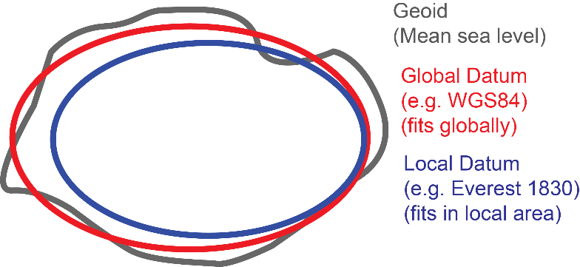

Figure 1: Geoid, Global datum and Local datum

## Ellipsoid

* It is a mathematically defined smooth surface that approximates the shape of the Earth.
* For example - WGS84, Everest 1830, etc.

## Datum

* Datum consists of horizontal datum and vertical datum.
* It established coordinate system to locate any position on earth
* Horizontal datum is used to find latitude and longitude
* Vertical datum is used to find elevation and depths
* Key components of datum are- Reference point, Coordinate system, Orientation, Scale, Ellipsoid.

## Global datum

* It approximates the geoid of earth and represents the position of any location on earth
* It is frame of reference used all over the world
* This datum is used for positioning by Global Positioning System (GPS).
* For example: WGS84
* Global datum is shown in Figure 1.

## Local datum

* It approximates the geoid of earth and represents the position of specific country i.e. the position of location obtained using local datum is correct for specific region but erroneous for other regions.
* For example: Everest 1830 for Nepal, the North American Datum of 1927 and the Australian Geodetic Datum of 1966
* Local datum is shown in Figure 1.

## Transformation

* It is the process of converting geodetic coordinates (Latitude, longitude, ellipsoidal height) from one datum to another.
* Suppose, the survey data is collected in WGS84 datum but map needs to be produced in Everest1830 datum then transformation needs to be performed to convert from WGS84 geodetic coordinates to Everest1830
* Seven Parameter Transformation is one of the methods used for transformation

## Projection

* It refers to the process of representing 3D earth surface on 2D or flat surface
* Some of the methods used for projection are- Cylindrical projection, Conical projection, Azimuthal projection, etc.
* Universal Transverse Mercator (UTM), which is of cylindrical projection type, is generally used for mapping

## UTM

* UTM stands for Universal Transverse Mercator
* It is cylindrical type projection, which results in minimum distortion at central meridian while distortion increases as you move away from central meridian
* It divides Earth into 60 zones, each zone of 6-degree longitudinal span
* Each zone has a central meridian which has scale factor 1
* The origin (0,0) is located at the intersection point of equator and central meridian
* To ensure that all the coordinates are positive, False easting is assumed to be 500,000.00 m and false northing as 0.00 m
* Nepal lies in zone 44N and 45N with central meridian 81-degree longitude and 87-degree longitude respectively which are represented as UTM81 and UTM87
* To find zone when central meridian (CM) is known: Zone = (CM + 180 + 3) / 6
  + For 81-degree longitude CM, Zone = (81+180+3)/6=44
* To find central meridian (CM) when zone is known: CM = Zone * 6 - 180 – 3
  + For Zone = 45, CM = 45*6-180-3 = 87 degree longitude

## MUTM

* MUTM stands for Modified Universal Transverse Mercator
* It is similar to UTM but is only applicable for Nepal and doesn’t have zones
* It has three central meridians namely 81-degree, 84-degree and 87-degree longitude which are represented as MUTM81, MUTM84, MUTM87.

## Height

### Orthometric height

* + Orthometric height, also known as elevation or orthometric elevation, refers to the vertical distance between a point on the Earth's surface and a defined vertical datum, usually the geoid or mean sea level as in Figure 2.
  + It accounts for the irregularities in the Earth's gravitational field
  + It is obtained by the use of levelling from a vertical control point

### Ellipsoidal height

* + It is the vertical distance above the Earth's ellipsoid as in Figure 2.
  + Also known as geometric height or spheroidal height
  + It doesn't consider variations in gravity or the actual irregularities on the Earth's surface.
  + It is obtained using Global positioning system (GPS) devices or satellite-based positioning systems.

### Geoid separation

* + It is the difference between Orthometric and ellipsoidal height as in Figure 2.
  + It isn't constant and varies from place to place due to irregularities in the Earth's gravitational field caused by variations in mass distribution.

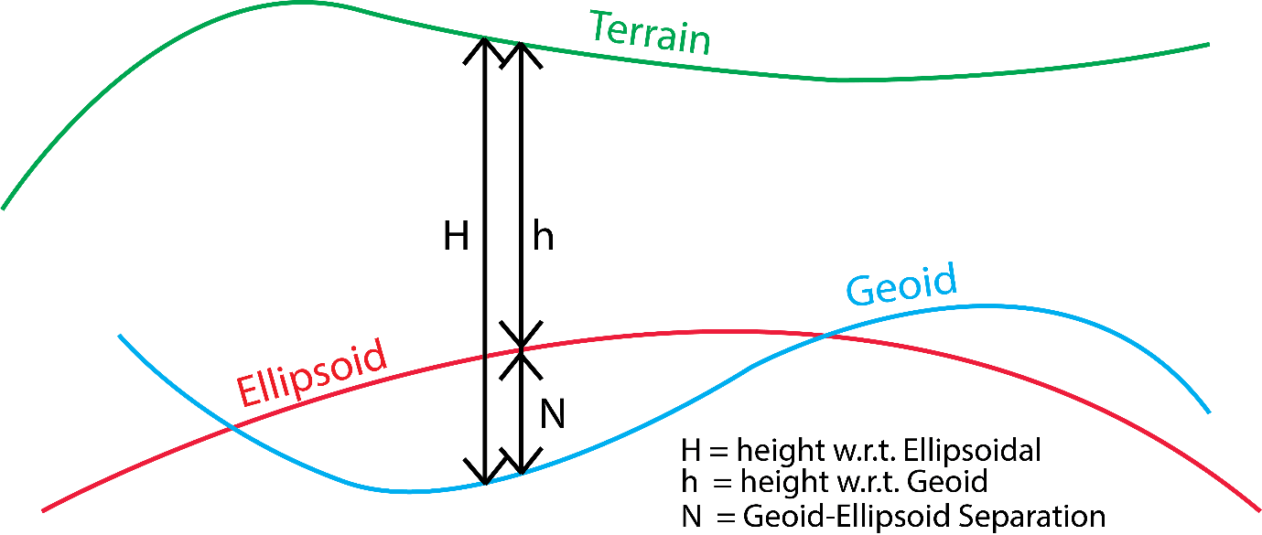

Figure 2: Ellipsoid and orthometric height

# Global datum and Local datum used in Nepal

## Global datum: WGS84 Parameters

* It is the global datum used all over the world.
* The Parameters of World Geodetic System WGS84 [1] are-

|  |  |
| --- | --- |
| Ellipsoid | WGS84 |
| Semi-major axis | 6378137.0 m |
| 1/f (Inverse flattening) | 298.257223563 |
| Angular unit in radian | 0.0174532925199433 |
| Prime Meridian | Greenwich 00 |

## Local datum: Everest 1830 Parameters

* Everest 1830 is local datum used in Nepal.
* The Parameters of Everest 1830 [1] are-

|  |  |
| --- | --- |
| Ellipsoid | Everest1830 |
| Semi-major axis | 6377276.345 m |
| 1/f (Inverse flattening) | 300.8017 |
| Angular unit in radian | 0.0174532925199433 |
| Prime Meridian | Greenwich 00 |

# Projection and Transformation

## Projection of WGS84

### Projection of WGS84 to UTM

* Projection of WGS84 Geodetic coordinates means converting Latitude, Longitude and Ellipsoidal height of datum WGS84 to UTM (Easting and Northing) of respective zone as shown in red dotted rectangle in Figure 3. [2]

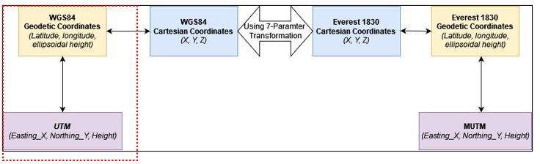

Figure 3: Projection of WGS84 to UTM and vice versa

### Parameters for projection from WGS84 to UTM

* The projection parameter from WGS84 to UTM and vice-versa are-

|  |  |
| --- | --- |
| Ellipsoid | WGS84 |
| Projection | UTM |
| Zone | *{Input zone in which projection is required}* |
| Semi-major axis in meter | 6378137.0 |
| 1/f | 298.257223563 |
| K0 | 0.9996 |
| M0 | 0 |
|  | 00 |
| False easting in meter | 500000.0 |

### Equations used to project from Geographic to UTM

* Following equations [3][4] can be used to project from any datum say WGS84, etc. to UTM.
  + - K = UTM scale factor
    - Easting is obtained by adding false easting to X
    - Northing is obtained by adding false northing to Y
    - φo = 0 (latitude of the central meridian at the origin of the x, y coordinates)
    - M = True distance along central meridian from the equator to φ (across from the point)
    - Mo = 0 (M at φo)
    - λo = longitude of central meridian (for UTM zone)
    - ko = 0.9996 (scale factor at the central meridian)
* To use the above equations for projection, any meridian can be chosen as the equations are general [4] and hence can be used for projection of coordinates of Everest1830 to MUTM as well.
* The above equation is for window of 6-degree longitude and K0 is 0.9996 for 6-degree zone. If conversion is to be done for larger or smaller window (i.e. more or less than 6-degree longitude zone) then value of K0 will be different[4] (which in case of MUTM with 3-degree longitude is 0.9999)
* If window is greater than 6-degree longitude, more terms need to be added to the equation above for avoid erroneous result [4]

### Equations used to convert from UTM to Geographic

* Following equations [3] can be used to project from any datum say WGS84, etc. to UTM.
  + - is the footprint latitude or the latitude at the central meridian which has the same y coordinates as that of the point
* Put values of x, y in above equation after deducting False Easting and False Northing respectively.

### Projection of Map of Nepal from WGS84 to UTM

* The map of Nepal projected in UTM is shown in Figure 4, which shows that Nepal lies in two Zones i.e. 44N and 45N with 81-degree and 87-degree longitude as central meridian of the zones respectively.
* The following table describes the use of zone and central meridian as per location within Nepal for UTM projection-

|  |  |  |  |
| --- | --- | --- | --- |
| **Lower bound longitude of location** | **Upper bound longitude of location** | **Zone** | **Central Meridian** |
| up to extreme west of Nepal | 84 | 44N | 81 |
| 84 | Up to extreme east of Nepal | 45N | 87 |

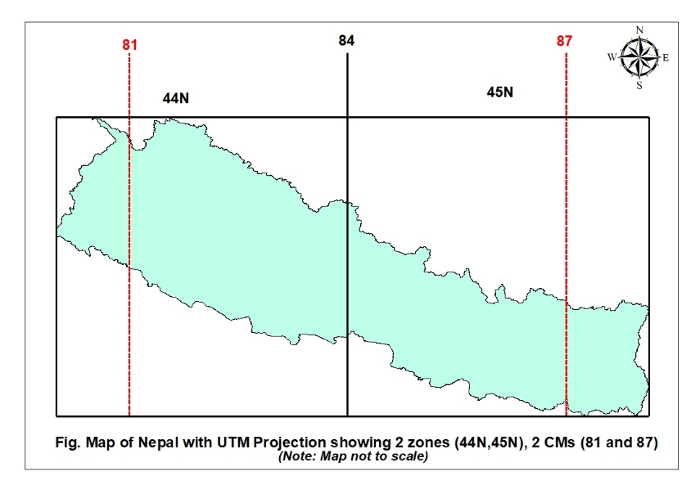

Figure 4: Map of Nepal in UTM Projection

## Projection of Everest 1830

### Projection of Everest 1830 to MUTM

* Projection of Everest 1830 Geodetic coordinates means converting Latitude, Longitude and Ellipsoidal height of datum Everst 1830 to MUTM (Easting and Northing) for respective Central Meridian as shown in red dotted rectangle Figure 5.
* For MUTM (Modified Universal Transverse Mercator), there are no zones.

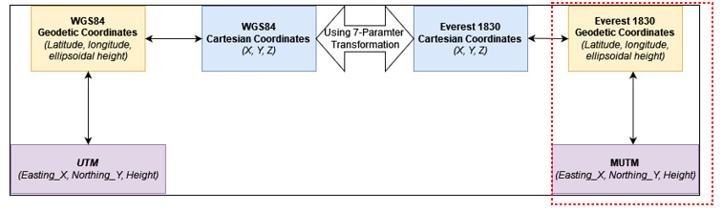

Figure 5: Projection of Everest 1830 to MUTM and vice versa

### Projection parameter of Everest 1830 to MUTM

* The projection parameter from Everest 1830 to MUTM and vice-versa are-

|  |  |
| --- | --- |
| Ellipsoid | Everest 1830 |
| Projection | MUTM |
| Zone | {Input zone in which projection is required} |
| Semi-major axis in meter | 6377276.345 |
| 1/f | 300.8017 |
| K0 | 0.9999 |
| M0 | 0 |
|  | 00 |
| False easting in meter | 500000.0 |

### Projection of Map of Nepal from Everest 1830 to MUTM

* The map of Nepal projected in MUTM is shown in Figure 6, which shows that there are three central meridians namely, 81-degree, 84-degree and 87-degree longitude.
* The following table describes the use central meridian as per location within Nepal for MUTM projection-

|  |  |  |
| --- | --- | --- |
| **Lower bound longitude of location** | **Upper bound longitude of location** | **Central Meridian** |
| Up to extreme West of Nepal | 82.5 | 81 |
| 82.5 | 85.5 | 84 |
| 85.5 | Up to extreme East of Nepal | 87 |

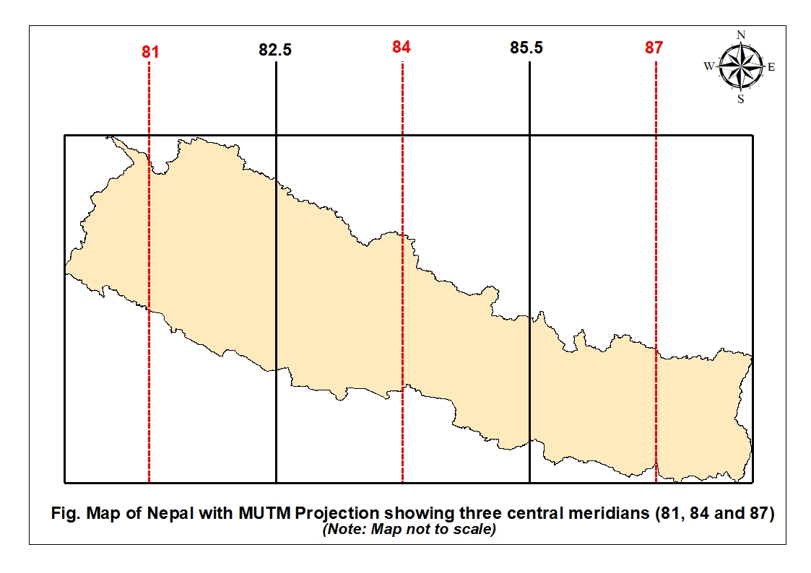

Figure 6: Map of Nepal in MUTM

## Transformation from WGS84 to Everest 1830 and vice versa

### Steps for Transformation

* The Transformation from Datum A (WGS84) to Datum B (Everest 1830) can be divided into three Steps.
* **Step 1**: **Geodetic of Datum A to Cartesian of Datum A**
  + Computing Cartesian Coordinates from Geodetic coordinates of Datum A (WGS84) using formula [5], [6] as below and as shown in Figure 7.
    - (T1)
    - (T2)
    - (T3)
    - where,
      * (T4)
      * (T5)
      * X, Y, Z, a, b, v, h are in meters

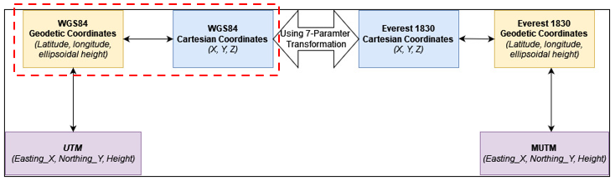

Figure 7: Step 1 (Geodetic to Cartesian conversion)

* **Step 2**: **Cartesian of Datum A to Cartesian of Datum B**
  + Transforming Cartesian Coordinates of Datum A (WGS84) to Cartesian coordinates of Datum B (Everest 1830) using formula of “**7-Parameter transformation”** as below and as shown in Figure 8. [5], [6]
    - (T6)
    - where the following seven parameters are-
      * s = scale factor (unitless), if ‘s’ is in ppm then divide ‘s’ by
      * , , are translation factor in meter
      * , , are rotation factors in radian
  + The seven parameters are given to transform from datum A to datum B as shown in equation (T6)
  + If you have to convert from datum B to datum A then multiply all the seven parameters by -1 then put those new values in the equation (T6)

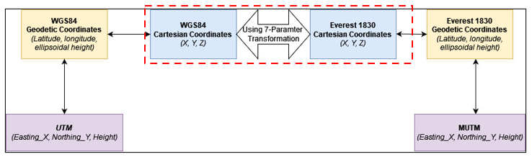

Figure 8: Step 2 (Cartesian of Datum A to Cartesian of Datum B)

* **Step 3**: **Cartesian of Datum B to Geodetic of Datum B**
  + Transforming Cartesian Coordinates of Datum B (Everest 1830) to Geodetic coordinates of Datum B (Everest 1830) using following formula as below and as shown in Figure 9. [5], [6]
    - (T7)
    - (T8)
    - (T9)
    - (T10)
  + The equation (T8) contains ‘Φ’ on both side of equation and hence needs to be solved by iteration.
  + **Steps to find ‘Φ’**
    1. Assume initial from
       - (T11)
    2. Calculate from (4) using
    3. Substitute obtained from (T11) in RHS of equation (T8) to obtain as-
       - (T12)
    4. Find error as difference between and
    5. Repeat from step (b) to (d) using new until the difference between latitudes are within the permissible limits.

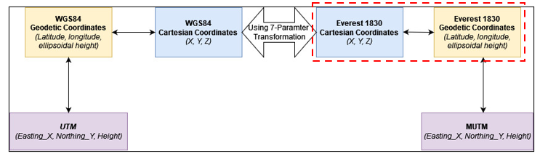

Figure 9: Step 3 (Cartesian of Datum B to Geodetic of Datum B)

## Flow chart of Projection and Transformation

### Flow chart

The flow chart of projection and transformation is as shown in Figure 10.

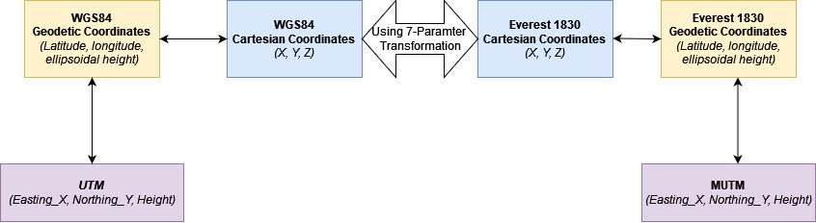

Figure 10: Flow chart of Projection and Transformation

As shown Figure 10, you can only follow the linear path for projection and conversion. The following example shows the order-

* **From UMT to MUTM**
  + UTM🡪WGS84 Geodetic Coord🡪WGS Cartesian Coord🡪Everest 1830 Cartesian🡪Everest1830 Geodetic Coord🡪MUTM
* **From MUMT to UTM**
  + MUMT🡪 Everest1830 Geodetic Coord🡪 Everest 1830 Cartesian🡪 WGS Cartesian Coord🡪 WGS84 Geodetic Coord🡪 UTM
* **From WGS84 Geodetic Coordinates to MUTM**
  + WGS84 Geodetic Coord🡪WGS Cartesian Coord🡪Everest 1830 Cartesian🡪Everest1830 Geodetic Coord🡪MUTM
* **From MUTM to WGS84 Geodetic Coordinates** 
  + MUMT🡪 Everest1830 Geodetic Coord🡪 Everest 1830 Cartesian🡪 WGS Cartesian Coord🡪 WGS84 Geodetic Coord

*Note: There’s no way to directly convert from UTM to MUMT and vice-versa or WGS84 Geodetic to MUTM and vice-versa. You have to follow the path as shown in* Figure 10*.*

# Software

## Introduction

|  |  |
| --- | --- |
| Name of the Software | **CSAY_LATLONG_UTM_TOFROM_CONVERTER** |
| Version | 2023.1 |
| Type | Free and Open source |
| Operating System | Windows 7, 8, 10, 11 |
| License | GNU GENERAL PUBLIC LICENSE V3.0 |
| Setup | No installation required |
| Link to download | https://github.com/ajayyadavay/CSAY_LatLongUTMToFrom_Converter |
| Created/Developed/Programmed by | Er. Ajay Yadav |
| E-mail: | [Civil.ajayyadav@gmail.com](mailto:Civil.ajayyadav@gmail.com) |
| Features: | a. Converts latitude, longitude to Easting, Northing  b. Converts Easting, Northing to latitude, longitude  c. Exports latitude, longitude to Kml  d. Exports converted table to excel  e. Allows user to choose their datum/ellipsoid  f. Allows datum transformation |

## Input data/file preparation

### Input parameter format for projection to MUTM

* Projection parameter for MUTM must be entered in the format shown in Figure 11 depending upon the Ellipsoid, Central Meridian.
* Here, you need to enter central meridian not zone as MUTM doesn’t have zones.
* It can be saved either with ‘*.txt’ or ‘.proj’ extension.

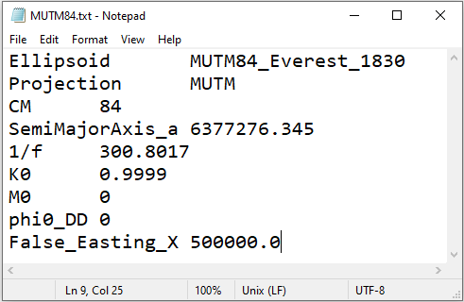

Figure 11: Projection parameter format for MUTM

### Input parameter format for projection to UTM

* Projection parameter for UTM must be entered in the format shown in Figure 12 depending upon the Ellipsoid, Zone
* Here you can enter either zone or central meridian as input
* It can be saved either with ‘*.txt’ or ‘.proj’ extension.

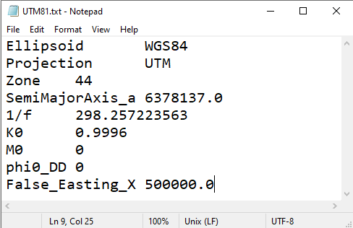

Figure 12: Projection parameter format for UTM

### Input data format for Easting, Northing

* The input data of Easting, Northing should be as shown in Figure 13
* It should be saved in ‘*.txt’ extension and data entered should be “tab delimited”
* This input file is required when you have known Easting and Northing (UTM or MUTM) of locations and you need to convert them to latitude and longitude (WGS84 or Everest 1830) using necessary projection parameters as in Figure 11 or Figure 12.

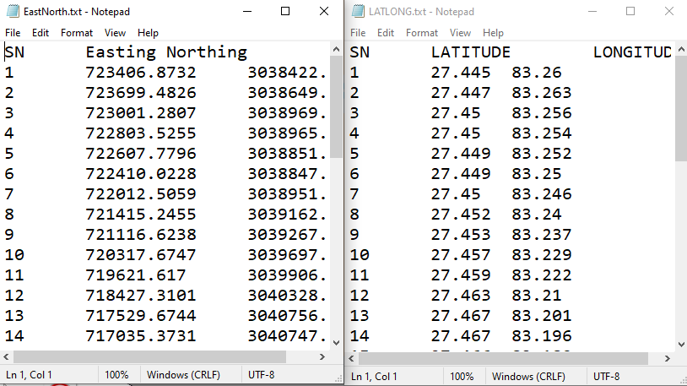

Figure 13: Easting, Northing input format

### Input data format Latitude, Longitude

* The input data of latitude, longitude should be as shown in Figure 14
* It should be saved in ‘*.txt’ extension and data entered should be “tab delimited”
* This input file is required when you have Latitude, Longitude (WGS84 or Everest 1830) of locations and you need to convert them to Easting and Northing (UTM or MUTM) using necessary projection parameters as in Figure 11 or Figure 12.



Figure 14: Latitude, Longitude input format

### Datum transformation parameter input format

* Datum transformation using 7 parameter transformation method from one datum (e.g. WGS84) to another (e.g. Everst 1830) must be entered in the format shown in Figure 15. [1]
* It can be saved either with ‘*.txt’ extension.

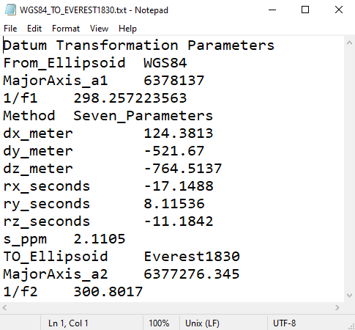

Figure 15: Datum transformation parameter input format

### Input data format for datum transformation

* The input data of latitude, longitude should be as shown in Figure 16.
* It should be saved in ‘*.txt’ extension and data entered should be “tab delimited”
* This input file is required when you have Latitude, Longitude (e.g. WGS84) of locations and you need to transform them to Latitude, Longitude of another datum (e.g. Everest 1830) using necessary transformation parameters as in Figure 15.

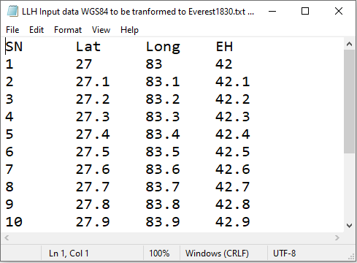

Figure 16: Input data format for datum transformation

### Input parameter file location

* Input parameter files can be read by software from only specific folders
* UTM or MUTM parameters (as in Figure 11 and Figure 12) must be located in “Ellipsoid” folder as shown in Figure 17.
* Datum transformation parameter (as in Figure 15) must be located in “DatumTransformation” folder as shown in Figure 17.

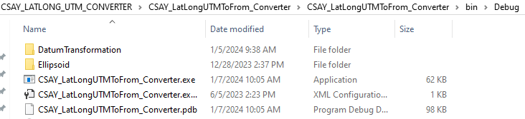

Figure 17: Input parameter files location

### Input data file and ‘.exe’ file location

* Input data file (as shown in Figure 13, Figure 14 and Figure 16) can be located anywhere in your computer because to you will be asked import it through import dialogue box.
* Open “CSAY_LatLongUTMToFrom_Converter.exe” to run the software

## Menu of Projection Module

### Home page

* When you run the software, the first page you will see is as shown in Figure 18.
* From drop down “Choose file (*.proj/*.txt) in Ellipsoid Folder”, choose projection parameter as shown in Figure 11, Figure 12.
* “Enter No. of rows to generate” will be enabled once you choose Input format as “Generate rows” under “Setting” menu. Then enter no. of rows to generate and then enter input data manually or past values in table (grey area shown in Figure 18).
* At the bottom of home page (Figure 18), you can see status bar which shows which settings you have selected.
* The “Zone” is in red color (Figure 18), which means that you need to input zone (Figure 11) and CM will be automatically calculated.

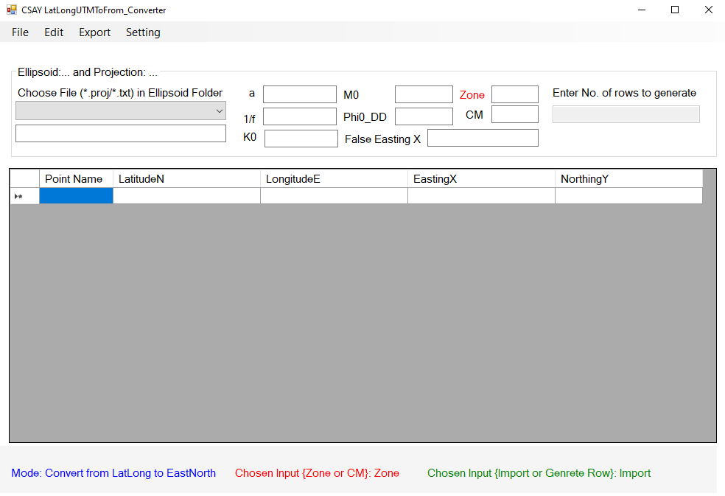

Figure 18: Home page of software

### File Menu

* File menu is as shown in Figure 19.

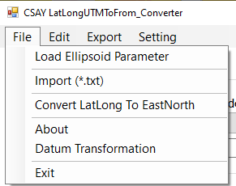

Figure 19: File Menu of Projection module

#### Load Ellipsoid Parameter

* Click this menu after the selection of “.txt or *.proj” file as shown in Figure 11 or Figure 12 from drop down as shown in Figure 18.
* This will load parameters like a, K0, M0, false easting, etc.

#### Import (*.txt)

* Clicking this menu will ask you to choose location of files as shown in Figure 13 or Figure 14 and imports these files into the table (grey area shown in Figure 18).
* This is enabled by default
* If you choose “Generate grid rows” in setting menu (as in Figure 24) then this menu will be disabled and you cannot import input files.

#### Convert LatLong To EastNorth

* Once you have imported or entered data into the table (grey area shown in Figure 18), you can click this menu to convert latitude and longitude to Easting and Northing
* Once you select mode “EastNorth to LatLong” in “setting>Mode” menu (as in Figure 22), this menu will change to “Convert EastNorth to LatLong”

#### About

* This consists of information about the software

#### Datum Transformation

* This will open another module named “Datum Transformation” as shown in Figure 25, where you can perform transformation from one datum to another as explained in section 3.3.

#### Exit

* This will close the software

### Edit menu

* Edit menu is as shown in Figure 20.

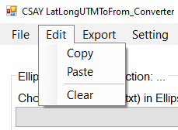

Figure 20: Edit menu

#### Copy

* This menu will copy data from table along with header (grey area shown in Figure 18)

#### Paste

* This menu will paste data to table (grey area shown in Figure 18)

#### Clear

* This menu will clear all data of table (grey area shown in Figure 18)

### Export

* Export menu is as shown in Figure 21.

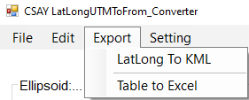

Figure 21: Export menu

#### LatLong To KML

* This will export latitude, longitude of table (grey area shown in Figure 18) to *.kml file

#### Table to Excel

* This will export whole table (grey area shown in Figure 18) to excel file

### Setting>Mode Menu

* Setting>Mode menu is as shown in Figure 22.

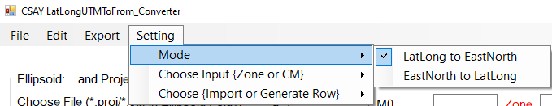

Figure 22: Setting>Mode menu

#### LatLong to EastNorth

* When you click this menu,
  + it will be checked (as shown in Figure 22)
  + file menu (Figure 19) section 4.3.2.3 will show “Convert LatLong to EastNorth”
  + The table (grey area shown in Figure 18), will show header from 3rd to 6th column in order “LatitudeN, LongitudeE, EastingX, NorthingY” respectively.
  + You need to import input file format as shown in Figure 14 because input is Latitude, Longitude and output is Easting and Northing

#### EastNorth to LatLong

* When you click this menu,
  + it will be checked
  + file menu (Figure 19) section 4.3.2.3 will show “Convert EastNorth to LatLong”
  + The table (grey area shown in Figure 18), will show header from 3rd to 6th column in order “EastingX, NorthingY, LatitudeN, LongitudeE” respectively.
  + You need to import input file format as shown in Figure 13 because input is Easting and Northing and output is Latitude, Longitude

### Setting>Choose {Zone or CM}

* Setting> Choose {Zone or CM} menu is as shown in Figure 23.

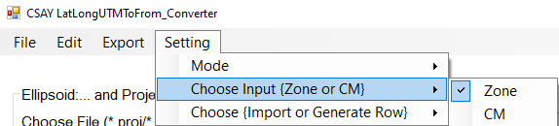

Figure 23: Setting>Choose {Zone or CM} menu

#### Zone

* When you click this menu,
  + “Zone” (shown in Figure 18) will be orange colored
  + The projection parameter “*.proj” or “*.txt” should contain zone input as in Figure 12
  + Central Meridian (CM) will be automatically calculated

#### CM

* When you click this menu,
  + “CM” will be orange colored
  + The projection parameter “*.proj” or “*.txt” should contain CM input as in Figure 11
  + Zone will be automatically calculated

### Setting>Choose {Import or Generate Row}

* Setting> Choose {Import or Generate Row} menu is as shown in Figure 24.

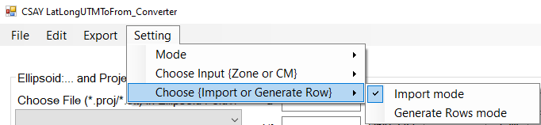

Figure 24: Setting> Choose {Import or Generate Row} menu

#### Import Mode

* When you click this menu,
  + “Import (*.txt”)” menu (shown in Figure 19 and section 4.3.2.2) will be enabled while text box for “Enter no. of rows to generate” (shown in Figure 18) will be disabled
  + As a result, you can import input files as shown in Figure 13 and Figure 14
  + You can also drag files shown in Figure 13 and Figure 14 in the grey area shown in Figure 18 to import these files.

#### Generate Rows mode

* When you click this menu,
  + “Import (*.txt”)” menu (shown in Figure 19 and section 4.3.2.2) will be disabled while text box for “Enter no. of rows to generate” (shown in Figure 18) will be enabled
  + As a result, you can’t import input files as shown in Figure 13 and Figure 14
  + Instead, you need to enter no. of rows to generate table and enter data manually or paste into the table

## Menu of Datum Transformation Module

### Datum Transformation

* When you click the menu mentioned in section 4.3.2.5, the dialogue box/form you will see as shown in Figure 25.
* Once you choose transformation parameter from drop down “Choose (*.txt) in Datum Transformation Folder”, all the parameter data shown in Figure 15 will be displayed after clicking import ellipsoidal data menu.

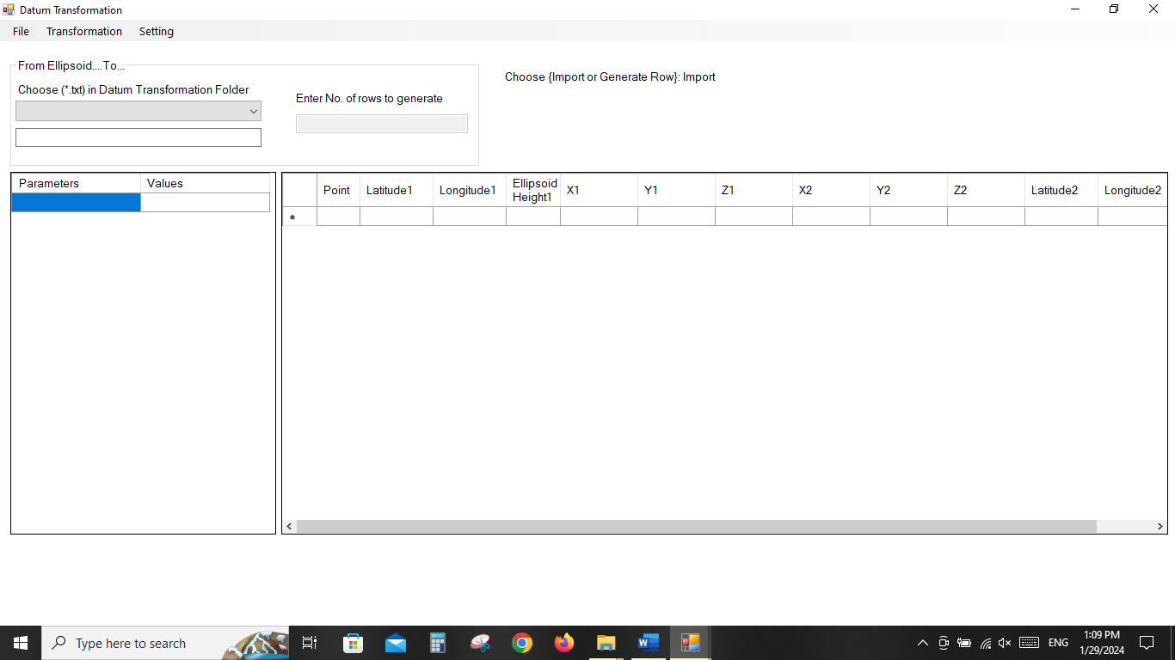

Figure 25: Datum transformation module first page

### File menu

* File menu is as shown in Figure 26.

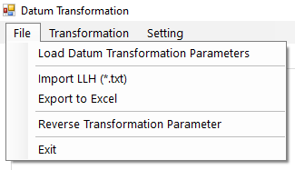

Figure 26: Datum Transformation File Menu

#### Load Datum Transformation Parameters

* Clicking this menu after choosing parameter file (as shown in Figure 15) from drop down “Choose (*.txt) in Datum Transformation Folder” of Figure 25 will load datum transformation parameters

#### Import LLH (*.txt)

* It will import input data as shown in Figure 16.
* LLH means Latitude, Longitude and Ellipsoidal Height

#### Export to Excel

* It will export whole table of Datum transformation to excel.

#### Reverse Transformation parameter

* It will multiply all the Seven Parameters by -1 and interchange parameters of datum 1 and datum 2.
* If you have transformation parameter (Figure 15) from datum 1 (e.g. WGS84) to datum 2 (e.g. Everest180) but you need to transform from Everst1830 to WGS84 then click this menu to get the required parameter.
* Instead of clicking this menu, you can prepare parameter in txt file in “Datum Transformation” Folder (Figure 17) and load it (section 4.4.2.1).

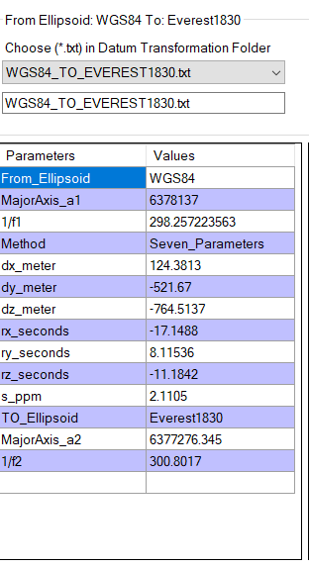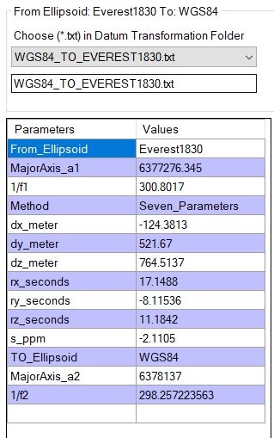

Figure 27: Before and after clicking “Reverse Transformation parameter”

#### Exit

* This will close this form/dialogue box/module

### Transformation Menu

* This menu is shown in Figure 28

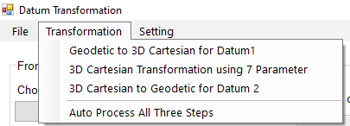

Figure 28: Transformation Menu

#### Geodetic to 3D Cartesian for datum

* This will accomplish task of Figure 7

#### 3D Cartesian Transformation using 7 Parameter

* This will accomplish task of Figure 8

#### 3D Cartesian to Geodetic for Datum 2

* This will accomplish task of Figure 9

#### Auto process all three steps

* This will accomplish task of all three steps at once automatically as stated in section 4.4.3.1, 4.4.3.2 and 4.4.3.3

### Setting Menu

* This menu is shown in

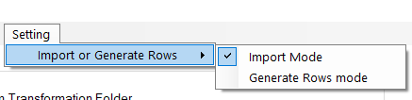

Figure 29: Setting menu of Datum Transformation

#### Import mode

* When you click this menu,
  + “Import LLH (*.txt”)” menu (explained in section 4.4.2.2) will be enabled while text box for “Enter no. of rows to generate” (shown in Figure 25) will be disabled
  + As a result, you can import input files as shown in Figure 16

#### Generate Rows mode

* When you click this menu,
  + “Import LLH (*.txt”)” menu (explained in section 4.4.2.2) will be disabled while text box for “Enter no. of rows to generate” (shown in Figure 25) will be enabled
  + As a result, you can input no. of rows to generate table and enter data manually or paste data into table as shown in Figure 25.

## Steps for Projection Module

1. Projection module uses equations as described in 3.1.3 and 3.1.4
2. Prepare projection parameter (refer Figure 11 or Figure 12)
3. Load projection parameter (refer section 204.3.2.1)
4. Choose required settings (refer sections 4.3.5, 4.3.6, 4.3.7)
5. Input data by import mode (refer 4.3.2.2) or generate rows mode (refer 4.3.7.2)
6. Click File>Convert From…To… (refer 4.3.2.3)
7. Export the result (refer 4.3.4)

## Steps for Datum transformation Module

1. Open datum transformation module (refer 4.3.2.5)
2. Prepare transformation parameter text file (refer 4.2.4)
3. Load transformation parameter file (refer 4.4.2.1)
4. Choose required settings (refer 4.4.4.1, 4.4.4.2)
5. Import input data file to transform from one datum to another (refer 4.4.2.2)
6. Click on transform menu and then to auto process (refer 4.4.3.4 or you can follow step by step transformation (refer 4.4.3.1, 4.4.3.2, 4.4.3.3 respectively)
7. Export the output file from file menu (refer 4.4.2.3)

## Some test data

* Consider locations in Lumbini, Nepal.
* WGS84 Latitude and longitude have been obtained from google earth and ellipsoidal height of WGS84 has been assumed.
* Using the WGS84 coordinates, following will be done-
  + Projected to UTM
  + Transformation to Everest 1830 datum
  + Projection of Everest 1830 coordinates to MUTM
* The test data is –

|  |  |  |  |
| --- | --- | --- | --- |
| Point Name | WGS84 Coordinates | | |
| Latitude | Longitude | Ellipsoidal height |
| P1 | 270 29' 0.06" | 830 16' 35.15" | 65.325 |
| P2 | 270 27' 45.41" | 830 17' 0.4" | 64.054 |
| P3 | 270 30' 18.49" | 830 16' 7.75" | 64.684 |

* The result generated using software are given in sections 4.7.1, 4.7.2, 4.7.3

### WGS84 to UTM test data

* Use parameters as shown in section 2.1 and section 3.1, Figure 12 and Figure 30
* Zone = 44N (Figure 4), CM = 81

|  |  |  |  |  |  |  |
| --- | --- | --- | --- | --- | --- | --- |
| Point Name | WGS84 Coordinates | | | UTM Projection, Zone = 44N | | |
| Latitude | Longitude | Ellipsoidal height (m) | Easting X in m | Northing Y in m | Ellipsoidal height (m) |
| P1 | 270 29' 0.06" | 830 16' 35.15" | 65.325 | 724917.042 | 3042035.245 | 65.325 |
| P2 | 270 27' 45.41" | 830 17' 0.4" | 64.054 | 725652.515 | 3039750.057 | 64.054 |
| P3 | 270 30' 18.49" | 830 16' 7.75" | 64.684 | 724120.657 | 3044435.745 | 64.684 |

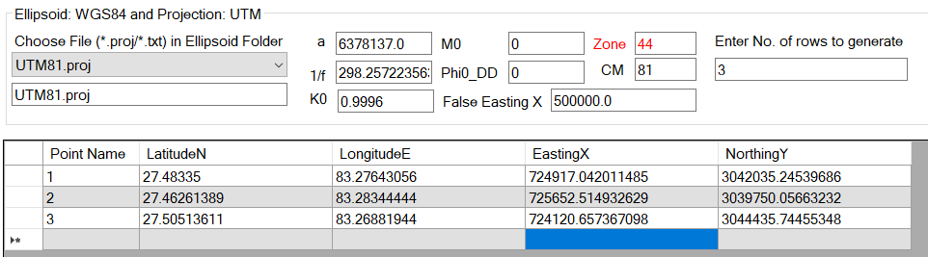

Figure 30: Test data from WGS84 to UTM

### WGS84 to Everest 1830

* Use parameter as shown in Figure 15 and Figure 31.

|  |  |  |  |  |  |  |
| --- | --- | --- | --- | --- | --- | --- |
| Point Name | WGS84 Coordinates (datum 1) | | | Everest 1830 (datum 2) | | |
| Latitude | Longitude | Ellipsoidal height (m) | Latitude | Longitude | Ellipsoidal height (m) |
| P1 | 270 29' 0.06" | 830 16' 35.15" | 65.325 | 270 28' 58.75" | 830 16' 42.74" | 102.416 |
| P2 | 270 27' 45.41" | 830 17' 0.4" | 64.054 | 270 27' 44.09" | 830 17' 7.99" | 101.340 |
| P3 | 270 30' 18.49" | 830 16' 7.75" | 64.684 | 270 30' 17.18" | 830 16' 15.34" | 101.571 |

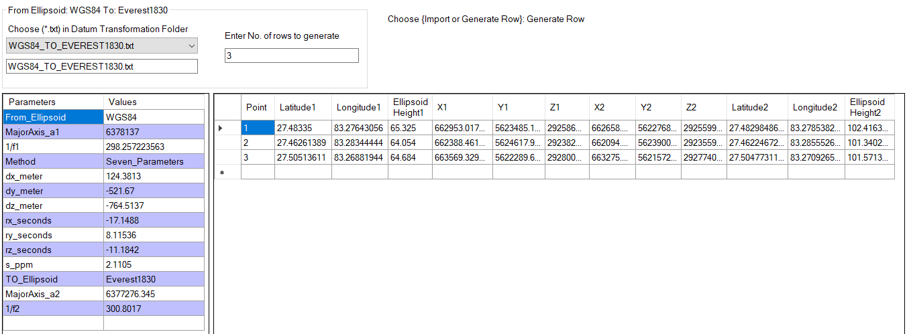

Figure 31: Test data transformation from WGS84 to Everst1830

### Everest 1830 to MUTM

* Use parameter as shown in Figure 11 and Figure 32.

|  |  |  |  |  |  |  |
| --- | --- | --- | --- | --- | --- | --- |
| Point Name | Everest 1830 Coordinates | | | MUTM Projection, CM = 84 | | |
| Latitude | Longitude | Ellipsoidal height (m) | Easting X in m | Northing Y in m | Ellipsoidal height (m) |
| P1 | 270 28' 58.75" | 830 16' 42.74" | 102.416 | 428715.955 | 3040795.374 | 65.325 |
| P2 | 270 27' 44.09" | 830 17' 7.99" | 101.340 | 429395.817 | 3038493.699 | 64.054 |
| P3 | 270 30' 17.18" | 830 16' 15.34" | 101.571 | 427978.040 | 3043213.792 | 64.684 |

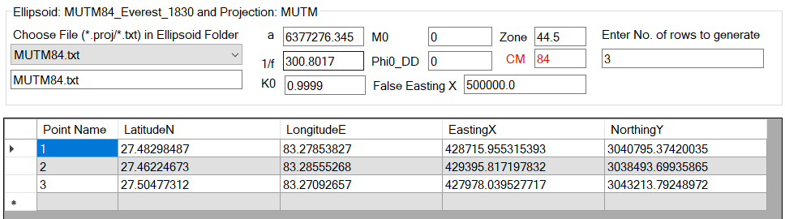

Figure 32: Test data projection of Everest 1830 to MUTM

# References

[1] N. Manandhar, “A REVIEW OF GEODETIC DATUMS OF NEPAL AND TRANSFORMATION PARAMETERS FOR WGS84 TO GEODETIC DATUM OF NEPAL,” *Journal on Geoinformatics, Nepal*, vol. 14, pp. 4–7, 2015.

[2] Beijing Institute of Technology, “Coordinates Conversion method between WGS84 ellipsoid and Clarke80 ellipsoid (CN101532834A),” 2009.

[3] J. P. Snyder, *Map Projection - A Working Manual*, vol. 1395 ch. 8. US Government Printing Office, 1987.

[4] J. G. Manchuk, “Conversion of Latitude and Longitude to UTM Coordinates,” 2009. [Online]. Available: http://www.gpsy.com/gpsinfo/geotoutm/

[5] “A Guide to Coordinate Systems in Great Britain,” 2020. [Online]. Available: www.os.uk

[6] G. P. Gerdan and R. E. Deakin, “Transforming cartesian coordinates X,Y,Z to geographical coordinates φ, λ, h,” *Australian Surveyor*, vol. 44, no. 1, pp. 55–63, 1999, doi: 10.1080/00050326.1999.10441904.

* Free and open source
* Converts latitude, longitude (Geodetic coordinates) to Easting, Northing (UTM) and vice-versa
* Exports latitude, longitude to *.Kml file and excel
* Allows user to input their global or local datum/ellipsoid
* Allows datum transformation of datum e.g. from WGS84 to Everst1830 and vice-versa
* Manual includes all the equations used to develop the software and sample test data for Nepal

**Ajay Yadav**

**Features of software**